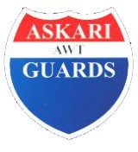**Askari Guards**

**7-Sarfraz Rafiqui Road Lahore Cantt. Tel: +92 42 36655751-3**

**S E C U R I T Y O F Y O U R I M A G I N A T I O N**

**TO WHOM IT MAY CONCERN**

It is certified that Mr. **<Name>** S/o **<fname>** worked in this organization w.e.f. <From> to <To> in the capacity of **<Designation>** at Royal Housing Society Lahore

His performance has been exemplary a nd to the entire satisfaction of his superiors. He is professionally sound and his approach to his work indicates zeal and enthusiastic to learn. He is an honest, punctual and devoted person. He bears a good moral character.

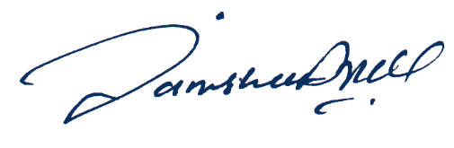

###### Lt Col (R) Manzoor Hussain